Dissertation Summary (3 pages)

SG-XDEAT: Sparsity-Guided Cross-Dimensional and Cross-Encoding Attention with Target-Aware Conditioning in Tabular Learning

1. Introduction
Tabular data, comprising samples (rows) with the same set of features (columns), plays a crucial role in numerous real-world applications that span various domains, including medicine, finance, and transportation [1, 2, 3]. Nevertheless, due to the lack of spatial and sequential structure from tabular data [3], deep learning can’t perform well compared to machine learning methods such as Gradient-Boosted Decision Trees (GBDTs) [1], which is an ensemble method that combines multiple weak decision trees into a strong predictive model. Hence, there is growing interest in developing deep networks for tabular data [4], such as FT-Transformer, an attention-based model adapting the Transformer architecture [5] to learn interactions between features [6], GANDALF, a graph-based architecture using built-in feature selection and gating mechanisms to learn feature representations [7], and TabLLM, a large language model (LLM)-based approach that converts tabular data into text-like representations and leverages pretrained LLM's prior knowledge [8], with the aim of challenging machine learning methods. Furthermore, research has explored the potential benefits of incorporating label information into feature encoding [9], such as Generalized Linear Mixed Model (GLMM) [10], to improve model performance in tabular data. Moreover, research has indicated that deep learning models for tabular data are particularly vulnerable to irrelevant or weakly informative features [11].
The research goal of this paper is to design a deep learning framework that effectively incorporates label information into feature representations while maintaining robustness against non-informative features. To address these challenges, we propose a novel deep architecture named SG-XDEAT, consisting of three main modules. The Target-Aware Conditioning module introduces label-guided encodings to enhance feature representation. The Dual-Path Transformer jointly models feature interactions and encoding dependencies through two parallel attention streams. Finally, the Adaptive Sparse Self-Attention module maintains a varying degree of information using distinct activation functions to balance global context and feature sparsity.
The contributions of this paper are summarized as follows:
- Target-Aware Conditioning A tokenization stream with label-guided encodings is introduced, employing Piecewise Linear Encoding for numerical features [12], which divides the numerical feature range into several intervals (bins) and encodes each value based on its relative position within these bins, and Decision Tree Encoding [13] for categorical ones, which encodes categorical variables using prediction values derived from decision trees.
- Dual-Path Transformer Two parallel attention streams are designed to jointly learn feature-level and encoding-level dependencies, including Cross-Encoding Self-Attention, which models relationships between raw and label-informed representations, and Cross-Dimension Self-Attention, which exchanges information across features.
- Adaptive Sparse Self-Attention A hybrid attention module is proposed to suppress noisy features while maintaining global context in Cross-Dimension Self-Attention module, combining a softmax-based activation branch, which normalizes attention scores into a probability distribution, globally focusing on relevant features, and a squared-ReLU-based activation branch [14], which applies the ReLU function to remove negative attention scores and then squares the remaining positive values, emphasizing essential feature interactions.
- Comprehensive Evaluation The effectiveness and efficiency of SG-XDEAT are validated through extensive experiments, demonstrating its ability to bridge the gap between deep models and GBDTs.

2. Related Work
2.1. Traditional Methods
Gradient Boosting Decision Trees (GBDT), including XGBoost [15], Light-GBM [16], and CatBoost [17], are widely used for tabular data due to their ability to handle mixed feature types, missing values, and non-linear patterns. These models offer strong predictive performance and remain the default choice in many structured data applications.
2.2 Deep Learning Models
Early work on deep learning for structured data relied on MLPs, yet these simple feed-forward networks rarely matched the performance of GBDT. Researchers then imported residual mechanism in ResNet, proving unexpectedly competitive [6]. More advanced models like AutoInt [18], DCN-V2 [19], Neural Oblivious Decision Ensembles (NODE) [20], and FT-Transformer [6] emerged, narrowing the performance gap between deep learning and GBDT on structured data.
2.3 Target Aware Encoding
Despite a variety of encoding strategies, traditional methods such as one-hot and ordinal encoding [21] do not incorporate any supervision from the target label. To address this, recent work has introduced label-aware encodings, particularly for categorical features [10, 22, 23], such as M-estimate [24] and DecisionTreeEncoder [13]. Similar ideas extend to numerical features: Piecewise Linear Encoding with Target guidance [12].
2.4. Noise-Robust for Deep Learning Model
Deep tabular models are often susceptible to irrelevant or weakly informative features [11], which can undermine both robustness and performance. Thus, many studies have increasingly focused on integrating noise suppression directly into the model architecture, such as ExcelFormer [25] and Leaky Gate [26]. To address this issue, Adaptive Sparse Self-Attention [14] module, originally developed for vision tasks, is integrated in SG-XDEAT to enhance noise robustness.
2.5 Dual-Path Transformer
In time-series forecasting and classification tasks, it is common to apply attention along separate time and variable axes, such as CrossFormer [27] and TimeXer [28]. In my tabular setup, each feature has two parallel representation streams after target-aware encoding: the raw value and its label-guided version. Thus, SG-XDEAT uses a dual-path attention structure: one path models across features within a stream (i.e., within the raw value or within the label-guided version), while the other models cross-stream interactions.

3. Methodology
Figure 1 presents the overall architecture of SG-XDEAT. The raw inputs are first processed by the Dual-Stream Embedding block, generating two parallel streams: a raw stream that retains the original values, and a target-aware stream that encodes label-informed representations. Next, the Token Extension adds learnable tokens to both streams, enabling the model to capture encoding-wise and feature-wise information. Then, these streams are passed through a Dual-Path Transformer stack. In each layer, (i) Cross-Encoding Self-Attention captures the dependencies between raw and target-aware information of each feature, while (ii) Cross-Dimension Self-Attention, equipped with an Adaptive Sparse Self-Attention module, facilitates information exchange across features while filtering out less informative tokens through various activation functions. After layers, the global tokens are mean-pooled and merged via the Token Aggregation module before being passed to the final classifier.
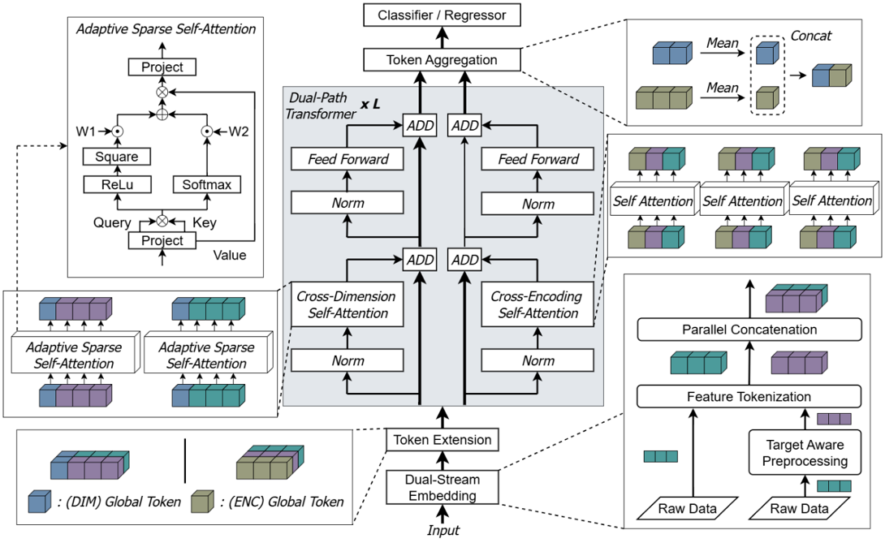

Figure 1: The overview of SG-XDEAT. L is the layer number.

4. Experiments
4.1. Dataset
To evaluate the robustness and generalizability of the model proposed in this paper, a set of benchmark datasets covering regression, binary classification, and multiclass classification tasks is adopted. The datasets vary in feature composition; some are only numerical, others entirely categorical, and some include both. The selected datasets are Gesture Phase (GE) [29], KDD Internet Usage (KD) [30], Adult (AD) [31], California Housing (CA) [32], and Higgs Small (HI) [33].

4.2. Baseline
The approach was evaluated against a range of baselines commonly used for tabular data. Traditional methods include gradient boosting models such as XGBoost [15]. Deep learning baselines include a standard MLP [6] and several advanced architectures: ResNet [6], DCN-V2 [19], AutoInt [18], and FT-Transformer [6]. This selection ensures a comprehensive comparison across both machine learning and deep learning models.
4.3. Implementation Details
All deep learning models were evaluated using the same preprocessing: quantile transformation for input features. In addition, regression targets were standardized across all methods. All models were trained using the AdamW optimizer, along with a cosine annealing scheduler. A linear warm-up strategy was applied during the first 10 epochs, and each model was trained for a maximum of 200 epochs. Early stopping was employed with a patience of 15 epochs based on validation performance. Moreover, the hyperparameters of the models were tuned individually for each dataset and were based on the Optuna framework [34].
4.4. Experiment Results
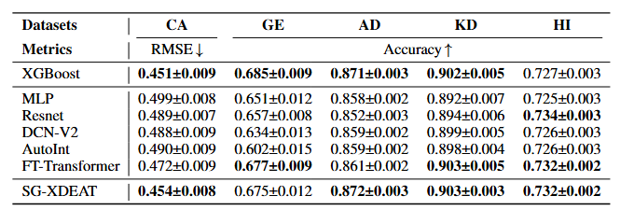
Table 1 presents a comprehensive comparison of benchmark models across five tabular datasets. Among all baseline deep learning-based methods, SG-XDEAT clearly stands out in most datasets. It also outperforms the machine learning-based method (XGBoost), achieving the best average rank among all baseline models, underscoring its robustness and strong generalizability. To assess the statistical significance of performance differences, the one-sided Wilcoxon test [35] with a significance level of α = 0.05 with Bonferroni correction is applied.
Table 1: Comparison of performance across various benchmark models. Performance is reported as mean ± standard deviation. The best result and those not statistically different from it are shown in bold.

5. Conclusion
SG-XDEAT, a sparsity-guided attention framework, is designed for deep learning on tabular data. By capturing both cross-feature and cross-encoding dependencies through a dual-path attention design, SG-XDEAT effectively leverages raw and label-informed representations. The incorporation of an adaptive sparse attention mechanism further improves robustness by suppressing noisy or low-relevance signals. The framework can effectively incorporate label information into feature representations while maintaining robustness against non-informative features, directly aligning with the research goal. Empirical results across a range of benchmarks show that SG-XDEAT consistently outperforms strong baselines, helping close the gap between deep models and gradient-boosted decision trees.

References
- Ravid Shwartz-Ziv and Amitai Armon. Tabular data: Deep learning is not all you need. Information Fusion, 81:84–90, 2022.
- Vadim Borisov, Tobias Leemann, Kathrin Seßler, Johannes Haug, Martin Pawelczyk, and Gjergji Kasneci. Deep neural networks and tabular data: A survey. IEEE transactions on neural networks and learning systems, 35(6):7499–7519, 2022.
- Shriyank Somvanshi, Subasish Das, Syed Aaqib Javed, Gian Antariksa, and Ahmed Hossain. A survey on deep tabular learning. arXiv preprint arXiv:2410.12034, 2024
- Yejin Hwang and Jongwoo Song. Recent deep learning methods for tabular data. Communications for Statistical Applications and Methods, 30(2):215– 226, 2023.
- Ashish Vaswani, Noam Shazeer, Niki Parmar, Jakob Uszkoreit, Llion Jones, Aidan N Gomez, Lukasz Kaiser, and Illia Polosukhin. Attention is all you need. Advances in neural information processing systems, 30, 2017.
- Yury Gorishniy, Ivan Rubachev, Valentin Khrulkov, and Artem Babenko. Revisiting deep learning models for tabular data. Advances in neural in- formation processing systems, 34:18932–18943, 2021.
- Manu Joseph and Harsh Raj. Gandalf: gated adaptive network for deep automated learning of features. arXiv preprint arXiv:2207.08548, 2022.
- Stefan Hegselmann, Alejandro Buendia, Hunter Lang, Monica Agrawal, Xiaoyi Jiang, and David Sontag. Tabllm: Few-shot classification of tabular data with large language models. In International conference on artificial intelligence and statistics, pages 5549–5581. PMLR, 2023.
- Jun-Peng Jiang, Si-Yang Liu, Hao-Run Cai, Qile Zhou, and Han-Jia Ye. Representation learning for tabular data: A comprehensive survey. arXiv preprint arXiv:2504.16109, 2025.
- Walter W Stroup, Marina Ptukhina, and Julie Garai. Generalized linear mixed models: modern concepts, methods and applications. Chapman and Hall/CRC, 2024.
- Duncan McElfresh, Sujay Khandagale, Jonathan Valverde, Vishak Prasad C, Ganesh Ramakrishnan, Micah Goldblum, and Colin White. When do neural nets outperform boosted trees on tabular data? Advances in Neural Information Processing Systems, 36:76336–76369, 2023.
- Yury Gorishniy, Ivan Rubachev, and Artem Babenko. On embeddings for numerical features in tabular deep learning. Advances in Neural Informa- tion Processing Systems, 35:24991–25004, 2022.
- Alexandru Niculescu-Mizil, Claudia Perlich, Grzegorz Swirszcz, Vikas Sind- hwani, Yan Liu, Prem Melville, Dong Wang, Jing Xiao, Jianying Hu, Moninder Singh, et al. Winning the kdd cup orange challenge with en- semble selection. In KDD-Cup 2009 competition, pages 23–34. PMLR, 2009.
- Shihao Zhou, Duosheng Chen, Jinshan Pan, Jinglei Shi, and Jufeng Yang. Adapt or perish: Adaptive sparse transformer with attentive feature refine- ment for image restoration. In Proceedings of the IEEE/CVF conference on computer vision and pattern recognition, pages 2952–2963, 2024
- Tianqi Chen and Carlos Guestrin. Xgboost: A scalable tree boosting sys- tem. In Proceedings of the 22nd acm sigkdd international conference on knowledge discovery and data mining, pages 785–794, 2016.
- Guolin Ke, Qi Meng, Thomas Finley, Taifeng Wang, Wei Chen, Weidong Ma, Qiwei Ye, and Tie-Yan Liu. Lightgbm: A highly efficient gradient boosting decision tree. Advances in neural information processing systems, 30, 2017.
- Liudmila Prokhorenkova, Gleb Gusev, Aleksandr Vorobev, Anna Veronika Dorogush, and Andrey Gulin. Catboost: unbiased boosting with categori- cal features. Advances in neural information processing systems, 31, 2018.
- Weiping Song, Chence Shi, Zhiping Xiao, Zhijian Duan, Yewen Xu, Ming Zhang, and Jian Tang. Autoint: Automatic feature interaction learning via self-attentive neural networks. In Proceedings of the 28th ACM in- ternational conference on information and knowledge management, pages 1161–1170, 2019.
- Ruoxi Wang, Rakesh Shivanna, Derek Cheng, Sagar Jain, Dong Lin, Lichan Hong, and Ed Chi. Dcn v2: Improved deep & cross network and practical lessons for web-scale learning to rank systems. In Proceedings of the web conference 2021, pages 1785–1797, 2021.
- Sergei Popov, Stanislav Morozov, and Artem Babenko. Neural oblivi- ous decision ensembles for deep learning on tabular data. arXiv preprint arXiv:1909.06312, 2019.
- Chris M Bird, Samuel C Berens, Aidan J Horner, and Anna Franklin. Categorical encoding of color in the brain. Proceedings of the National Academy of Sciences, 111(12):4590–4595, 2014.
- Michael Larionov. Sampling techniques in bayesian target encoding. arXiv preprint arXiv:2006.01317, 2020.
- Guoping Zeng. A necessary condition for a good binning algorithm in credit scoring. Applied Mathematical Sciences, 8(65):3229–3242, 2014.
- Daniele Micci-Barreca. A preprocessing scheme for high-cardinality cate- gorical attributes in classification and prediction problems. ACM SIGKDD explorations newsletter, 3(1):27–32, 2001.
- Jintai Chen, Jiahuan Yan, Qiyuan Chen, Danny Ziyi Chen, Jian Wu, and Jimeng Sun. Excelformer: A neural network surpassing gbdts on tabular data. arXiv preprint arXiv:2301.02819, 2023.
- James Fiedler. Simple modifications to improve tabular neural networks. arXiv preprint arXiv:2108.03214, 2021
- Yunhao Zhang and Junchi Yan. Crossformer: Transformer utilizing cross- dimension dependency for multivariate time series forecasting. In The eleventh international conference on learning representations, 2023.
- Yuxuan Wang, Haixu Wu, Jiaxiang Dong, Guo Qin, Haoran Zhang, Yong Liu, Yunzhong Qiu, Jianmin Wang, and Mingsheng Long. Timexer: Em- powering transformers for time series forecasting with exogenous variables. Advances in Neural Information Processing Systems, 37:469–498, 2024.
- Renata CB Madeo, Clodoaldo AM Lima, and Sarajane M Peres. Ges- ture unit segmentation using support vector machines: segmenting gestures from rest positions. In Proceedings of the 28th Annual ACM Symposium on Applied Computing, pages 46–52, 2013.
- Colleen M Kehoe and James E Pitkow. Surveying the territory: Gvu’s five www user surveys. The World Wide Web Journal, 1(3):77–84, 1996.
- Ron Kohavi et al. Scaling up the accuracy of naive-bayes classifiers: A decision-tree hybrid. In Kdd, volume 96, pages 202–207, 1996.
- R Kelley Pace and Ronald Barry. Sparse spatial autoregressions. Statistics & Probability Letters, 33(3):291–297, 1997.
- Pierre Baldi, Peter Sadowski, and Daniel Whiteson. Searching for exotic particles in high-energy physics with deep learning. Nature communica- tions, 5(1):4308, 2014.
- Takuya Akiba, Shotaro Sano, Toshihiko Yanase, Takeru Ohta, and Masanori Koyama. Optuna: A next-generation hyperparameter optimiza- tion framework. In Proceedings of the 25th ACM SIGKDD international conference on knowledge discovery & data mining, pages 2623–2631, 2019.
- Frank Wilcoxon. Individual comparisons by ranking methods. Biometrics bulletin, 1(6):80–83, 194

Other experiments, like Ablation Analysis of Architectural Components, Analysis of Different Input Strategies, and Effectiveness of Adaptive Sparse Self-Attention, are not discussed here. More details are provided in https://arxiv.org/abs/2510.12659

